Year 1 Home Learning Challenges - Spring 1
Here are your home learning challenges for this half term. Have a go at as many as you can and add a photo to your portfolio on ClassDojo!

English Challenge…  Can you write a story about friends who help each other when a problem occurs?  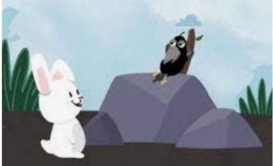 | Maths Challenge…  Practise your number bonds to 20!  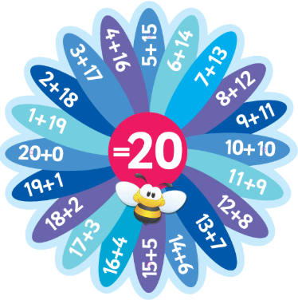 | Science Challenge…  Make a weather booklet to document the weather over a week!  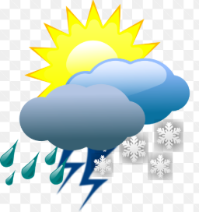
Mindful Challenge…  This challenge is about doing something you love doing. Something that makes you calm and happy!  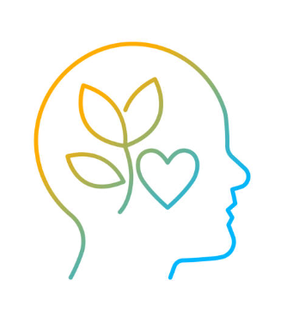 | DT Challenge…  Make a fruit kebab or smoothie for a snack!   | Geography Challenge…  Make the Union Jack flag out of any materials you choose!  


