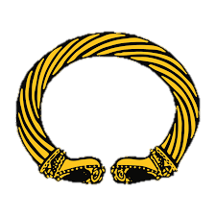
Reception:
We will have the opportunity to use the coding mouse.
Year 1:
We will be learning about Technology around us and how to use it.
Athletics
To understand directions & travel forwards, backwards, left & right.

History

Science

Maths

P.E.

English

P.S.H.C.E.

R.E.

Willow Class

What your child will be learning about in Autumn 1 2026?

Dear Parents and Carers,

We are excited to have creative outcomes from our knowledge curriculum this
term and for the children to learn new stories and facts to share. The children will be
learning how to think like a professional in each subject. Please encourage
children to read at home and write in their planners which book they have been reading.
We will be focusing on settling into out new year groups and getting to know the teacher.
Children the chance to ask any questions they might have and support will be given to any children who need it to ensure there is a smooth transition!

Kind Regards, The Willow Class team!

Computing

Art & DT

Geography

Reception:
Special people in our lives and around the world.
Year 1:
Christianity and the Creation Story.
Personal, Social, Health, Citizenship and Economic.
Children will learn about ‘Being Me in My world’. This will help them understand who they are, how they are feeling and why we need to be kind to everyone.
Reception:
Basic counting and learning numbers up to 10.

Year 1:
Number and place value to 10.
Reception:
The human body.

Year 1:
The human body.
Reception:
Different types of homes and where people live.
Year 1:
Spatial sense around my school.
Reception:
Being creative by drawing in my first sketchbook.
Year 1:
Colour and Line
Reception:
We will be learning the text ‘Finding a Friend’
Year 1:
We will be learning the text ‘Tom Cat’
Reception:
Families and what is family tree is.
Year 1:
Coming in Autumn 2…
Snettisham Primary School

