Ash’s Home Learning Challenges – Autumn Term 2 2025
We love seeing and sharing all the wonderful activities completed at home!
When you complete a piece of work, you can either bring it into school or post it online via Class Dojo.

English  Write a poem about Christmas. Make sure to use your best handwriting   | Science  Carry out a water cycle experiment.  Explain what evaporation and condensation are.  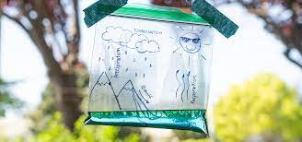 | Geography  Research and make a fact file about a country in Western Europe.  You could type up your research on a computer.   | Remember to read regularly!  Don’t forget to get an adult to write in your reading record so that you can earn your reading points.  
Design Technology  Make something using your sewing skills!   | History  Find out about the ancient Olympic Games. Design a new coin taking inspiration from the London 2012 ones  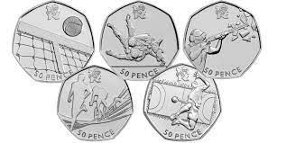 | PE  Make a gymnastics routine - how many holds and different ways of travelling can you link into a routine?  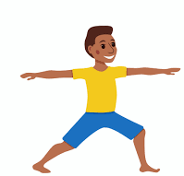 | Times Tables  Practice makes perfect!  Who will be our class champion and win the weekly certificate in assembly?  

