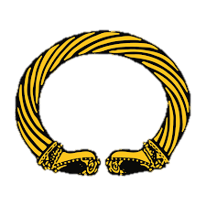

History

Science

Maths

P.E.

English

P.S.H.C.E.
(Personal, Social, Health, Citizenship, Economic Education)

R.E.

Ash Class

What your child will be learning about in Autumn 1 2026?

We are all looking forward to the start of a new school year at Snettisham Primary School with
Our new Ash Class team.
This term we will be busy learning lots of different units of work across our knowledge
rich curriculum with lots of enrichment opportunities to look forward to.

The Ash Class team!

Computing

Art & DT

Geography

Snettisham Primary School
Digital Media
We will use technology purposefully to create, organise, store, manipulate and retrieve digital content
We will recognise common uses of information technology beyond school or other online technologies.

History will not be taught in the 1st half term
Narrative – Journey Tale
We will learn and use our model text ‘The Papaya that Spoke’ to write a warning story using different sentence types, description and sequencing vocabulary
We will recognise the choices we make and understand the consequences.
We will understand the rights and responsibilities for being a member of our class and school.
Maps and Globes
We will know maps show us information about a location
We will use a map to plan a route.
Visual Arts
We will know that Matisse used organic shapes and complementary colours in his cut-outs.
We will learn that artists can show how something feels

Living Things
We will know that a habitat is the name given to a place where plants or animals live.
Year 2 – We will be learning about place value, addition and subtraction with numbers to 100

Year 3 - We will be learning about place value, addition and subtractions with numbers to 1000

OAA
We will follow & give verbal & written commands to move forwards and backwards

down, left and right.
Christianity
We will say when we have been kind to others, even when it was difficult.
We will know the Jesus taught Christians to be kind

