Year 1 Home Learning Challenges – Autumn 2
Here are your home learning challenges for this half term. Have a go at as many as you can and add a photo to your portfolio on ClassDojo. ☺

English Challenge…  Write a recount of somewhere you have been before. Remember a recount is something that has already happened.  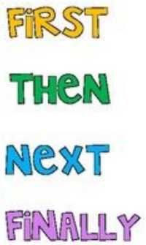 | Maths Challenge…  Time yourself saying the number bonds to 10! How speedy can you be…  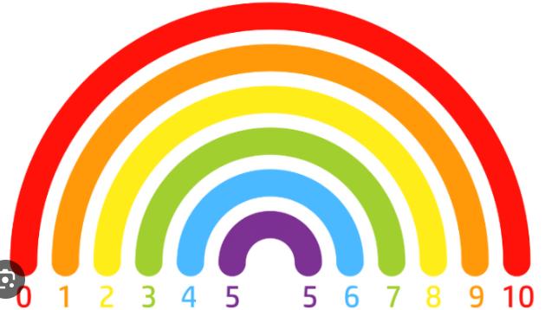 | Science Challenge…  Create a poster to explain how to look after an animal and what their needs are.  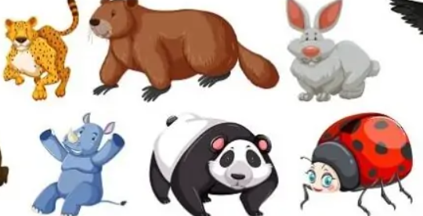
Mindful Challenge…  This challenge is about doing something you love doing. Something that makes you calm and happy!  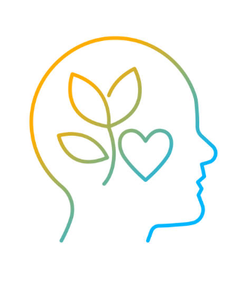 | Art Challenge…  Create a portrait of yourself using the different types of lines we learnt about last term.  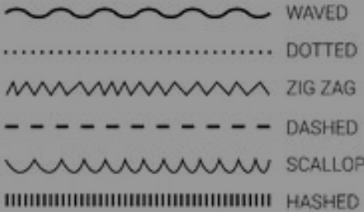 | History Challenge…  Can you find/draw items from the past and present?  