Ash’s Home Learning Challenges – Spring Term 1 2026
We love seeing and sharing all the wonderful activities completed at home!
When you complete a piece of work, you can either bring it into school or post it online via Class Dojo.

English  Write a ‘Warning Story.’ Remember to use your best handwriting.  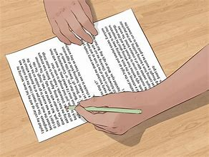 | Science  Research how fossils are created. Have a go at making your own fossils  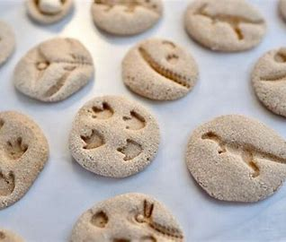 | Geography  Create your own settlement - you could draw it, use lego, a computer program or whatever you decide!  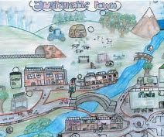 | Remember to read regularly!  Don’t forget to get an adult to write in your reading record so that you can earn your reading points.  
Art  Create your own Ancient Egyptian artwork or jewellery  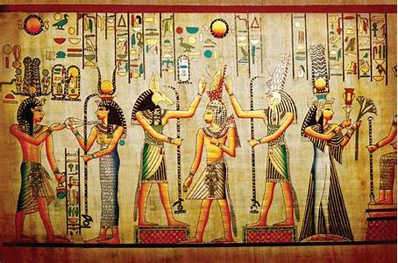 | Computing  Use a word document to type a story or information text. Save it and then make improvements to it. See if you can add a picture!  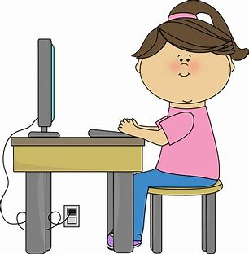 | History  Find out about the legend - Alexander the Great cutting the ‘Gordian Knot.’  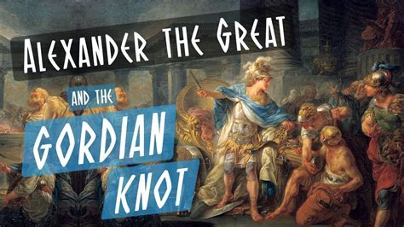 | Times Tables  Practice makes perfect!  Who will be our class champion and win the weekly certificate in assembly?  