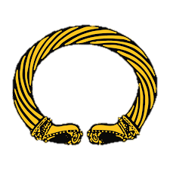
Reception:
We will have the opportunity to use the coding mouse.
Year 1:
We will have the opportunity to use the beebots.
Gymnastics
To understand how to move out bodies with control and to understand different balances.

History

Science

Maths

P.E.

English

P.S.H.C.E.

R.E.

Willow Class

What your child will be learning about in Autumn 2 2026?

Dear Parents and Carers,

We are excited to have creative outcomes from our knowledge curriculum this
term and for the children to learn new stories and facts to share. The children will be
learning how to think like a professional in each subject. Please encourage
children to read at home and write in their planners which book they have been reading.
We will be focusing enhancing our understanding of the new expectations of being in class.
Children will be practicing all the new skills like reading, writing and number skills over the next few weeks to embed the new learning.

Kind Regards, The Willow Class team!

Computing

Art & DT

Geography

Reception:
Children will learn about Christmas and Christianity.
Year 1:
We will be learning the Christmas Story.
Personal, Social, Health, Citizenship and Economic.
Children will learn about ‘Celebrating difference’. This will help them understand how they are different to everyone else and how to accept people for who they are.
Reception:
Comparing quantities, one more/less than a number.

Year 1:
Simple addition and subtraction.
Reception:
The seasons and weather.

Year 1:
Animals and their needs.
Reception:
Names of different places around the world.
Year 1:
Coming in Spring 1…
Reception:
Creating materials that are inspired by Diwali.
Year 1:
We will be exploring visual arts.
Reception:
We will be learning the text ‘The 3 little pigs’
Year 1:
We will be learning the text ‘The Country Museum’ and ‘Animals and their needs’
Reception:
Who was Guy Fawkes
Year 1:
We will be learning about how History has such an impact on our lives.
Snettisham Primary School

