Ash Class Home Learning Activities – Autumn Term 2 2026
In addition to regular reading and multiplication practice, please select at least two home learning activities from the subjects below.
Completed work can either be sent into school or posted online via Class Dojo by the 13th December.
We love seeing and sharing all the wonderful activities completed at home!
English  Write a newspaper report about an exciting event or somewhere you have been.   | Science  Create your own food chain. Can you label the producer, consumer and predator?  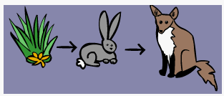 | DT  Make a moving Christmas picture using a slider or a lever.  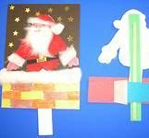 | Remember to read regularly!  Don’t forget to get an adult to write in your reading record so that you can earn your reading points.  
Maths  Practise adding and subtracting using the column method.  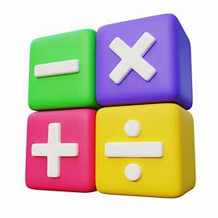 | History  Create Stonehenge using any media that you like.  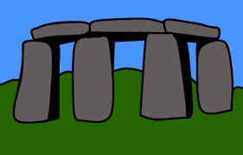 | RE  What do you know about Advent? Find out about the Christingle. Make your own.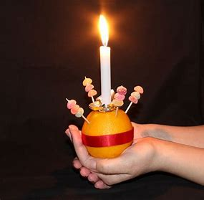 | Practice makes perfect!  Times Tables  Who will be our class champion and win the weekly certificate in assembly?  

