Year 1 Home Learning Challenges – Summer 2
Here are your home learning challenges for this half term. Have a go at as many as you can and add a photo to your portfolio on ClassDojo…you have until the end of July! ☺

English Challenge…  Can you make your own recipe for a potion? Can you make it afterwards?  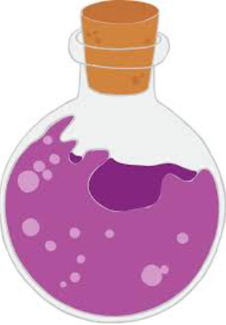 | Maths Challenge…  Can you practise partitioning numbers into 10s and 1s?  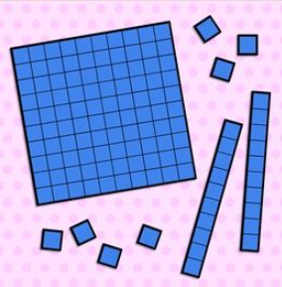 | Science Challenge…  Can you find anything magnetic at home?  Write a list of all the materials that attract magnets!  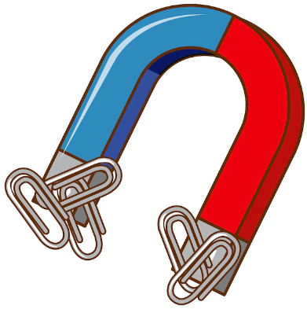
Mindful Challenge…  This challenge is about doing something you love doing. Something that makes you calm and happy!  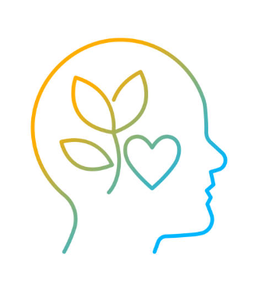 | Art Challenge…  Can you make an interesting freestanding sculpture?  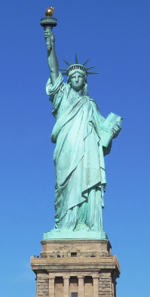 | Outdoor Challenge…  Can you make an obstacle course and send a video of you completing it?  