Year 1 Home Learning Challenges - Spring 2
Here are your home learning challenges for this half term. Have a go at as many as you can and add a photo to your portfolio on ClassDojo…you have until the end of March! ☺

English Challenge…  What things would you put into your basket to take to Grandma’s house? Challenge… Can you use adjectives?  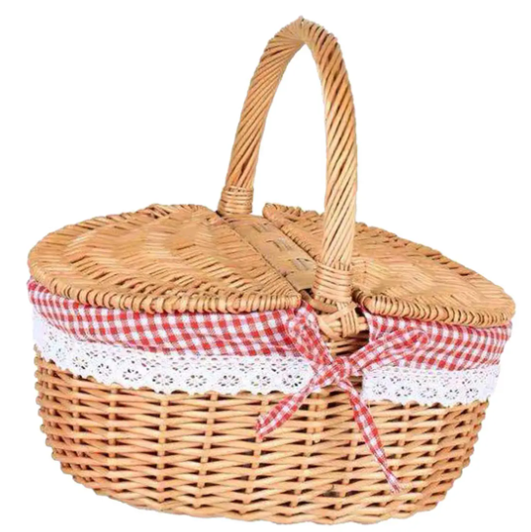 | Maths Challenge…  Can you share objects between equal groups?  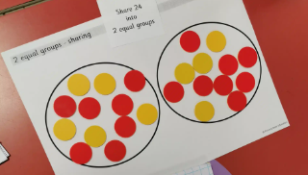 | Science Challenge…  Go on a litter pick around your local area. I wonder how many pieces of rubbish you can find?  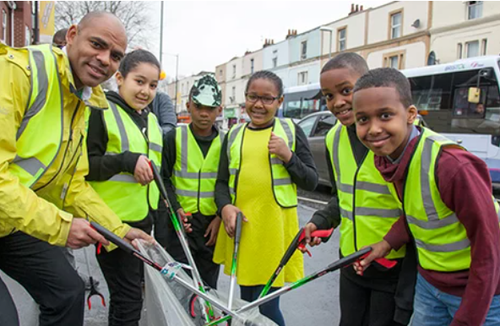
Mindful Challenge…  This challenge is about doing something you love doing. Something that makes you calm and happy!  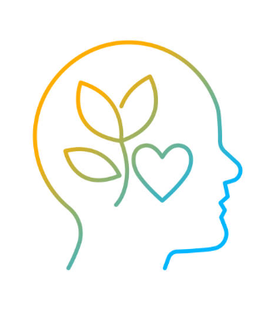 | Art Challenge…  Can you make a stained glass window? Top tip… stick it to your window and the light will shine through it!  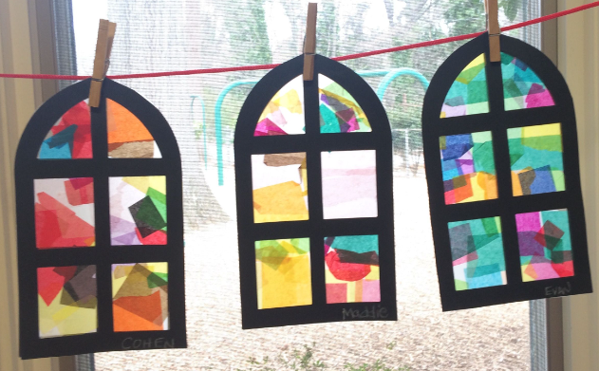 | History Challenge…  Can you make an Orb or Sceptre and pretend you are a King or Queen of the past?  


