Year 1 Home Learning Challenges – Summer 1
Here are your home learning challenges for this half term. Have a go at as many as you can and add a photo to your portfolio on ClassDojo… ☺

English Challenge…  Keep an eye out for an enormous rainbow? I wonder what might be at the end?   | Maths Challenge…  Share a whole piece of food equally between 2/4 people to show a half/quarters?  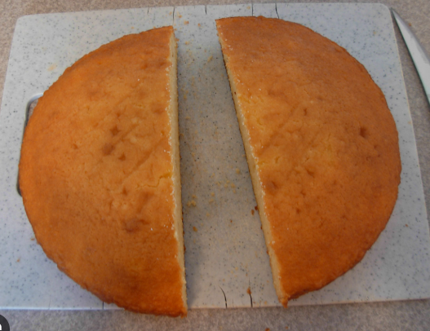 | Science Challenge…  Plant a flower and record how it grows?  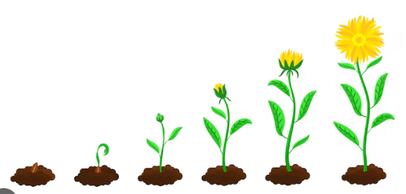
Mindful Challenge…  This challenge is about doing something you love doing. Something that makes you calm and happy!  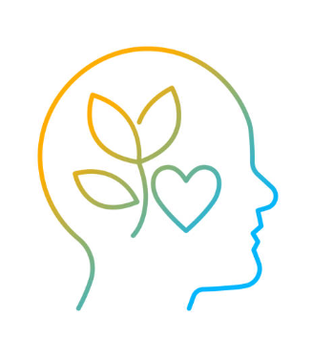 | Art Challenge…  Make a freestanding structure?  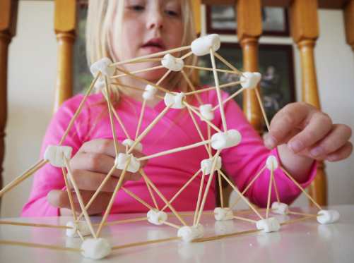 | Geography Challenge…  Think about what you know about the seven continents? Can you make a poster to showcase your knowledge?  