Ash’s Home Learning Challenges – Autumn Term 1 2025
We love seeing and sharing all the wonderful activities completed at home!
When you complete a piece of work, you can either bring it into school or post it online via Class Dojo.

English  Create a poster warning others about a dangerous character. Remember to add description.   | Science  Pick a flower and see if you can name all the parts.  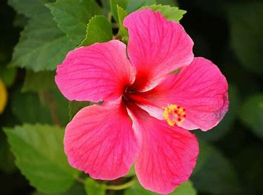 | Geography  Design a new village. Draw a map and add grid references to it.  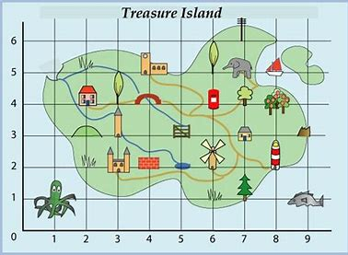 | Remember to read regularly!  Don’t forget to get an adult to write in your reading record so that you can earn your reading points.  
RE  Research Diwali and how it is celebrated. Make some decorations or food.   | History  Research Ancient Egypt.  Make a quiz using the information you find out.  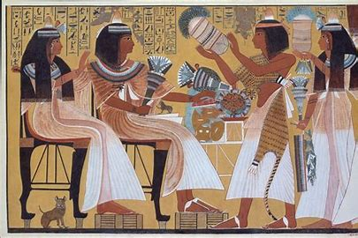 | PSHE  Write a detailed description about yourself. What are your likes, dislikes, hobbies?  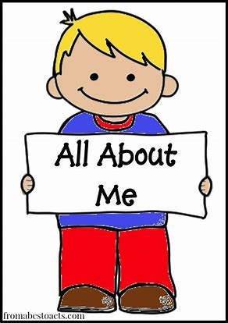 | Times Tables  Practice makes perfect!  Who will be our class champion and win the weekly certificate in assembly?  

