Year 1 Home Learning Challenges – Autumn 1
Here are your home learning challenges for this half term. Have a go at as many as you can and add a photo to your portfolio on ClassDojo. ☺

English Challenge…  Write the next adventure for Tom Cat! I wonder where he will end up…  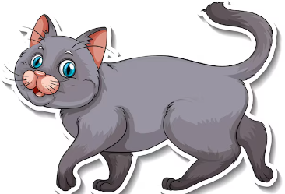 | Maths Challenge…  Use the more and less than symbols for counting something at home! <>  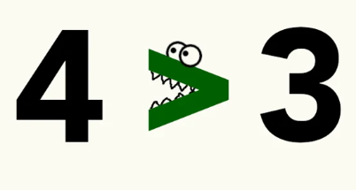 | Science Challenge…  Use your 5 sense at home... What can you see, feel, hear taste and smell?  
Mindful Challenge…  This challenge is about doing something you love doing. Something that makes you calm and happy!  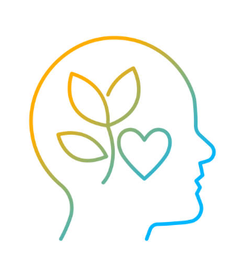 | Art Challenge…  What different items at home can you use to paint an interesting picture?  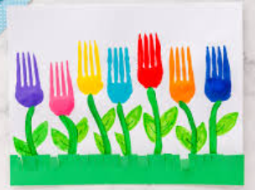 | Geography Challenge…  Make a map of your house? Make sure you include your bedroom, bathroom and kitchen! I wonder what other rooms you can draw …  