Ash home learning activities – Autumn Term 1 2026
In addition to regular reading and multiplication practice, please choose a home learning activity each week from the choices below.
Completed work can either be sent into school by Friday or shared on ClassDojo. We will look at this together each week.
We love seeing and sharing all the wonderful activities completed at home!
English  Write a story and illustrate it. Remember to use your best handwriting!   | Science  What animals and creatures use your garden or local park as their habitat? Design and make a bug hotel. Did you get any visitors?  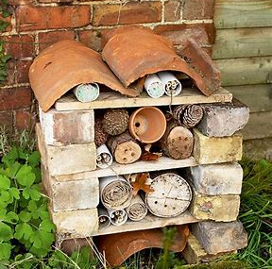 | Art  Research Kandinsky. Create a piece of art using his artwork as inspiration   | Remember to read regularly!  Don’t forget to get an adult to write in your reading record so that you can earn your reading points.  
Maths  How many different sums can you write that equal 100?   | Geography  Draw a map of your village. Remember to label it.  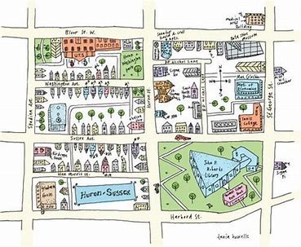 | PE  Time yourself running a distance (eg a lap of the playing field or laps of your garden) Keep practising over the next few weeks - can you improve your time? Can you increase the distance you run?  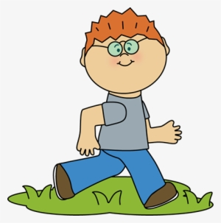 | Practice makes perfect!  Times Tables  Y2 - practise 10x and 2x  Y3 - practise 2x and 5x  

